Evaluation criteria:
- Assignee should know meaning of different java packages and usages of listed classes & interfaces. And comparison between two if any.
- Assignee should know methods available in each classes & interfaces listed below.
- Assignee must complete hands-on/coding on each method of listed classes & interfaces. And show their practice code during the evaluation.
- Assignee should be able to write the code using method, classes & interfaces for give use cases.

- java.lang.*; Week1
- Interfaces:
Cloneable, Iterable, Comparable & Runnable
- Classes:
All Wrapper classes, Object, String, StringBuffer, StringBuilder, Class, ClassLoader, Thread, Math, Number, Process, processBuilder, Runtime & System.
Exception, ArithmeticException, NullPointerException, NumberFormatException, RuntimeException, IndexOutOfBoundsException, ArrayIndexOutOfBoundsException, ClassCastException, ClassNotFoundException, CloneNotSupportedException
Error, LinkageError, OutOfMemoryError, StackOverflowError, NoClassDefFoundError

- java.util.*; week2
Java collection hierarchy:
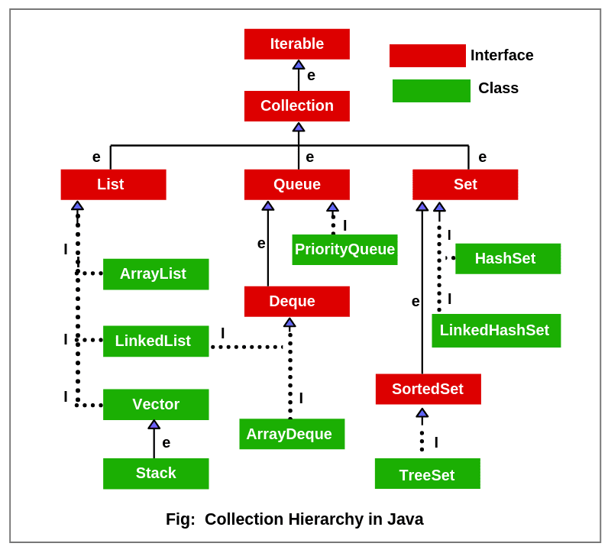

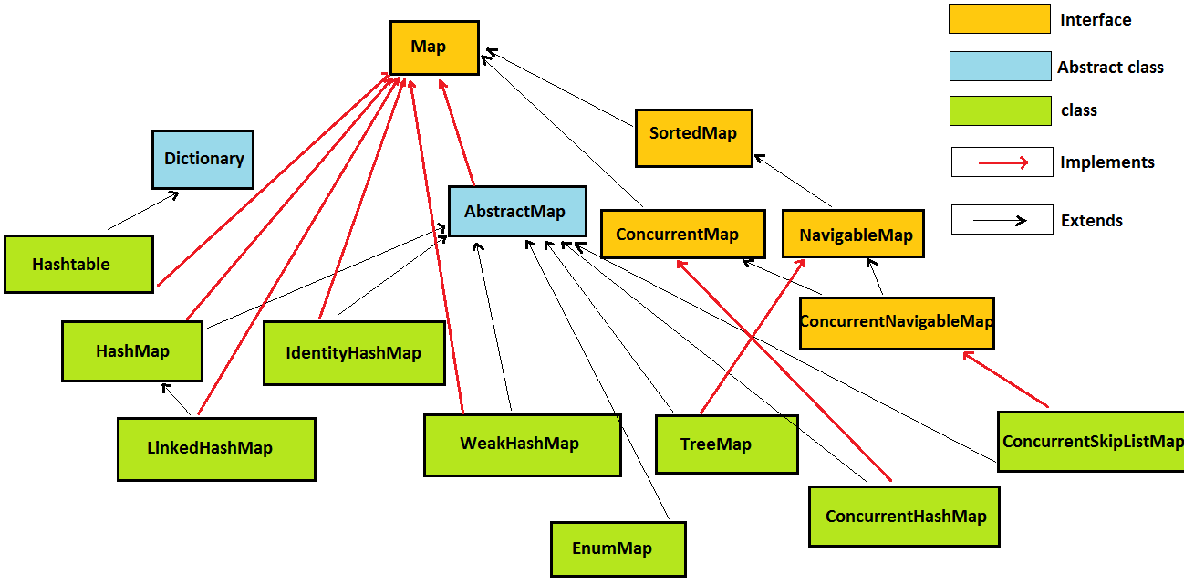
Other important classes & interface:
Arrays, Collections, Dictionary, Objects, Properties, Random, ResourceBundle, Scanner, UUID & StringTokenizer.
Comparator, Enumeration, Iterator, Map.Entry, RandomAccess.
Calendar, Date, Locale, TimeZone, Timer & TimerTask

- java.util.concurrent.*; Week3

Executor,ExecutorService, ScheduledExecutorService, BlockingDeque,BlockingQueue,Callable,ConcurrentMap & Future.
ConcurrentHashMap<K,V>,CopyOnWriteArrayList<E>,CopyOnWriteArraySet<E>,CountDownLatch,Executors,Semaphore & ThreadPoolExecutor

- java.util.stream.*; Week3

Stream, DoubleStream, IntStream, LongStream & Collector.
Collectors

- java.time.*; Week3

Clock, Duration, Instant, LocalDate, LocalDateTime, LocalTime, MonthDay, OffsetDateTime, OffsetTime, Period, Year, YearMonth, ZonedDateTime, ZoneId and ZoneOffset.

Other important:
java.time.format.DateTimeFormatter.
java.text.DateFormat
java.text.SimpleDateFormat

- java.math.*;
BigDecimal,BigInteger & MathContext

- java.io.*; Week4
- Byte Stream
- Byte Input Stream:
BufferedInputStream, ByteArrayInputStream, DataInputStream, FileInputStream,FilterInputStream, ObjectInputStream, PipedInputStream, SequenceInputStream
- Byte Output Stream:
BufferedOutputStream, ByteArrayOutputStream, DataOutputStream,
FileOutputStream , FilterOutputStream, ObjectOutputStream, PipedOutputStream, PrintStream
- Char Stream
- Char Reader Stream:
Reader, BufferedReader, CharArrayReader, FilterReader, InputStreamReader, FileReader, PipedReader & StringReader.
- Char Writer Stream:
Writer, BufferedWriter, CharArrayWriter, FilterWriter, OutputStreamWriter, FileWriter, PipedWriter, PrintWriter & StringWriter.
- Other important interfaces & classes:
Closeable, Flushable, Serializable, Externalizable, DataInput, DataOutput, ObjectInput & ObjectOutput.
File, FileDescriptor & StreamTokenizer.
IOException, EOFException, FileNotFoundException & InterruptedIOException

- java.net.*;

Inet4Address, Inet6Address, InetAddress, Socket, SocketAddress, SocketImpl, URI, URL, URLClassLoader & URLConnection.
BindException, ConnectException, SocketException, SocketTimeoutException, UnknownHostException, UnknownServiceException

- Java.sql.*;
Driver, Connection, Statement, CallableStatement, PreparedStatement, ResultSet, Blob, Clob. DriverManager, Date, Time, Timestamp.

